

**Testing for Category Part | Belayneh Mathewos**

**Testing for Category Part**

**Test Plan**

1.When retrieving item from shola database

* As much as possible to achieve the system that is at least 80% free from non-tolerable errors/defects.
* The system should be 80% free from defects

2.When seller upload his/her item

* As much as possible to achieve the system that is at least 85% free from non-tolerable errors/defects.
* The system should nearly be 85% free from defects

**Test case specifications**

1.When retrieving item from shola database

Test cases:

* If database is empty, what will happen to retrieve items.

2.When seller upload his/her item

Test cases:

* Image posting and retrieval should include all types.?
* All fields should be filled – if some field remains empty, will not be uploaded.

- tells the remaining field to the seller to fill it.

* Item name, description and category -any inputs(alphanumeric)

-If item name, … too large(can database store it?)

* Quantity, availability – integer(number) inputs
* price – double(number) input

***Sample code with simple modification***.

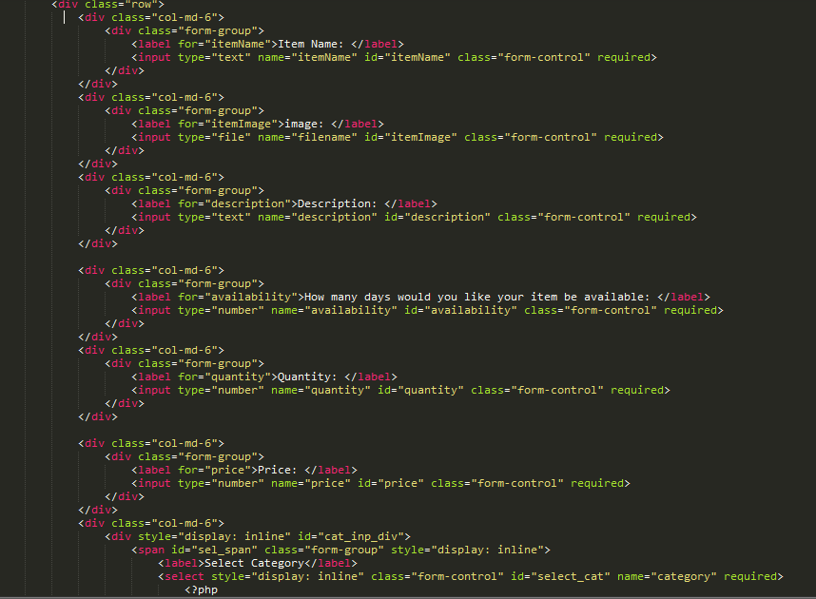

3. When a user product should be available/removed

* Within 2 second after seller uploads his products. Or as much as possible, as soon as uploader uploads his products, the product will be available for the sale.

**Results of the Test**

**THE RESULTS IN TABLE FORM**

Generally, tests of this module can be summarized as following.

**Test case for Uploading items**

|  |  |  |  |  |  |
| --- | --- | --- | --- | --- | --- |
| **TC**  **No.** | **Features** | **Description** | **Steps to Execute** | **Test Data/Input/ Expected** | **Successful** |
| 1 | Required fields | -Check the required fields by not filling any data | 1. Do not enter any value in the field 2. Click on Post button | -message should be displayed | YES |
| 2 | Required fields | -Check the required fields by not filling at least only one field | 1. Leave only one field empty 2. Click on Post button | --message should be displayed | YES |
| 3 | Required fields:  -name,  -description,  -category | -Check the required fields:  -name,  -description,  -category  by filling any input type | 1. Fill name,  description,  category by any input type with valid values in other required fields  2. Click on Post button | -S6 phone,  -smart phone with 4GB ram,..  -Phone | YES |
| 4 | Required fields:  -quantity,  -availability  -price | Check the required fields:  -quantity,  -availability  -price  by filling any input type | 1. Fil quantity,  Availability,  Price by any input type with valid values in other required fields  2. Click on Post button | -10  -60  -40000$ |  |
| 5 | Required fields:  -Image | Check the required fields:  -Image  by filling any input type | 1. Fil image by any input type with valid values in other required fields  2. Click on Post button | -will not be  Stored | YES |
| 6 | Required fields | -Check the required fields by filling all fields with valid values | 1. fill the all required fields with valid values 2. Click on Post button | -S6 phone,  -smart phone with 4GB ram,..  -Phone  -10  -60  -40000$ | -YES |
| 7 | Required fields | -Check the required fields by filling all fields with too large inputs, but valid data type | 1. enter too large inputs, but valid data types into all fields  2. Click on Post button | -Truncate  -S6 phone ..  -smart phone with 4GB ram,..  -Phone …  -10 …  -60 …  -40000…$ | -YES |